CS 405 SQL Injection Activity Summary
Caleb Sorell
May 14, 2026
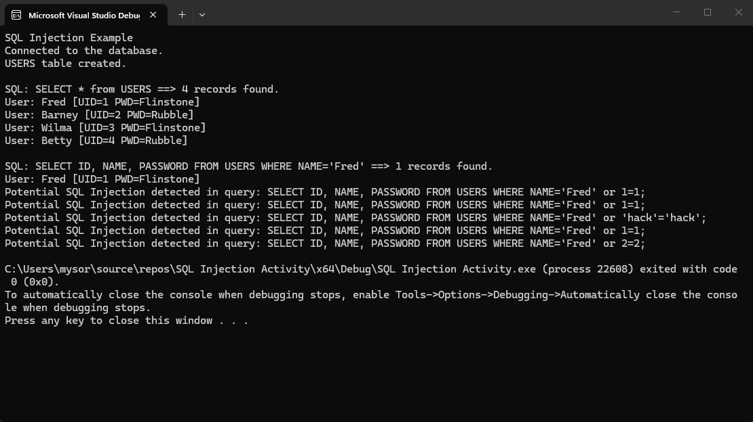
To defend against the SQL injection attack, I modified the run_query function to proactively inspect the incoming SQL string before it is ever passed to the SQLite database engine. Because relying on a simple string search (like looking specifically for 1=1) is easily bypassed by attackers using 2=2 or ‘hack’ = ‘hack’, I utilized the C++ <regex> library to detect the underlying logical pattern of the attack.
I implemented a regular expression tripwire: \bor\s+([0-9]+|’[^’]*’)\s*=\s*\1. This pattern searches for the word “or”, followed by either a numeric literal or a single-quoted string literal. The crucial component is the \1 backreference at the end, which strictly checks that the value immediately following the equals sign is completely identical to the value captured before it.
If std::regex_search detects this tautology pattern (where a value is equated to itself to force a TRUE condition), the function immediately aborts. It prints a warning to the console detailing the attempted malicious query, and returns false, entirely bypassing the sqlite3_exec() command and preventing the unauthorized data dump.
During development, I encountered an environment compilation issue where Visual Studio failed to map the startup file correctly due to the project being opened in Folder View rather than as a linked Solution. I resolved this by creating a new project entirely and adding the three necessary files to accomplish this assignment.
AI Use Disclosure & Acknowledgment
I utilized Gemini (Google AI) as a collaborative learning tool to assist in the completion of this assignment. Specifically, I consulted the AI to understand the mechanics of tautology-based SQL injection attacks (OR 1=1) and to brainstorm programmatic defenses. The AI assisted in formulating the precise Regular Expression (Regex) pattern required to catch dynamic values (such as 2=2 or 'hack'='hack') using backreferences. Additionally, the AI provided troubleshooting steps for Visual Studio compilation errors related to startup project configurations. Throughout this collaboration, I remained the primary author, manually implementing the code, debugging the local environment, and verifying the secure execution of the application.

